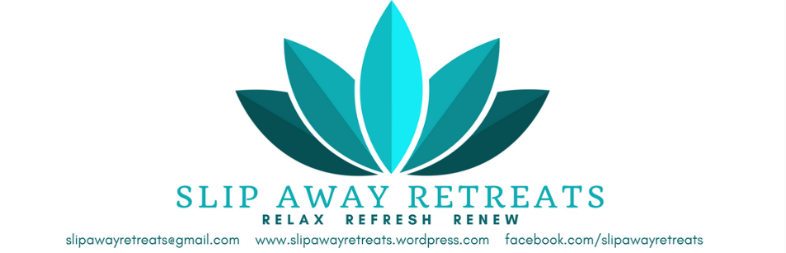

**Retreat Registration Form**

|  |
| --- |
| Name |
| Address |
| Phone Number |
| Email Address |
| Emergency Contact Name and Phone |
| Allergies |
| Sensitivities |
| Retreat name and date this registration is for |
|  |

Payment enclosed for:

Please make checks out to Yola Johnson.  
Mail completed registration form and check to   
Yola Johnson 21342 Knudsen Drive, Grosse Ile, MI 48138  
 -or-  
Email copy of completed form to [slipawayretreats@gmail.com](mailto:slipawayretreats@gmail.com)  
Send PayPal payment to slipawayretreats@gmail.com

* Early Bird $425
* Registration $450
* Late Registration $475
* Deposit (to hold your spot) $250

|  |
| --- |
| Have you ever attended a retreat before? |
| If so, what did you experience? |
|  |
| What is it important for you to experience with this retreat? |
|  |
|  |
| What are your favorite foods/drinks? |
|  |
| Please share something about yourself with us. |
|  |

Important Information  
Cancelation policy:   
Up to 30 days before event: $400 will be refunded  
29 to 14 days before event: $200 will be refunded  
**13 days or fewer before event 100% is non-refundable**